Assignment -03

Q2

**KeshavPorwal23I4143**

Q3 **KeshavPorwal23I4143**

Q4

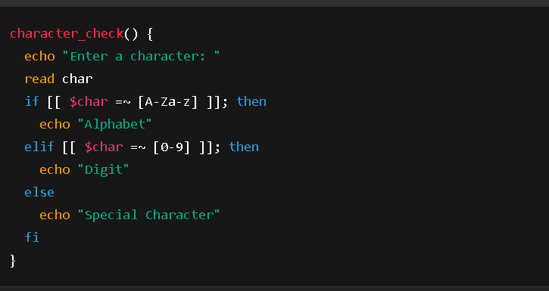

Q5

**KeshavPorwal23I4143**

Q6

**KeshavPorwal23I4143**

Q7

Q8 **KeshavPorwal23I4143**

Q9

**KeshavPorwal23I4143**

Q10

Q11

**KeshavPorwal23I4143**

**KeshavPorwal23I4143**